Lab 13

**Configure VPC Peering Between two VPC’s – 2 of 3**

We need to create VPC2 in Mumbai region,

Click “create VPC”.

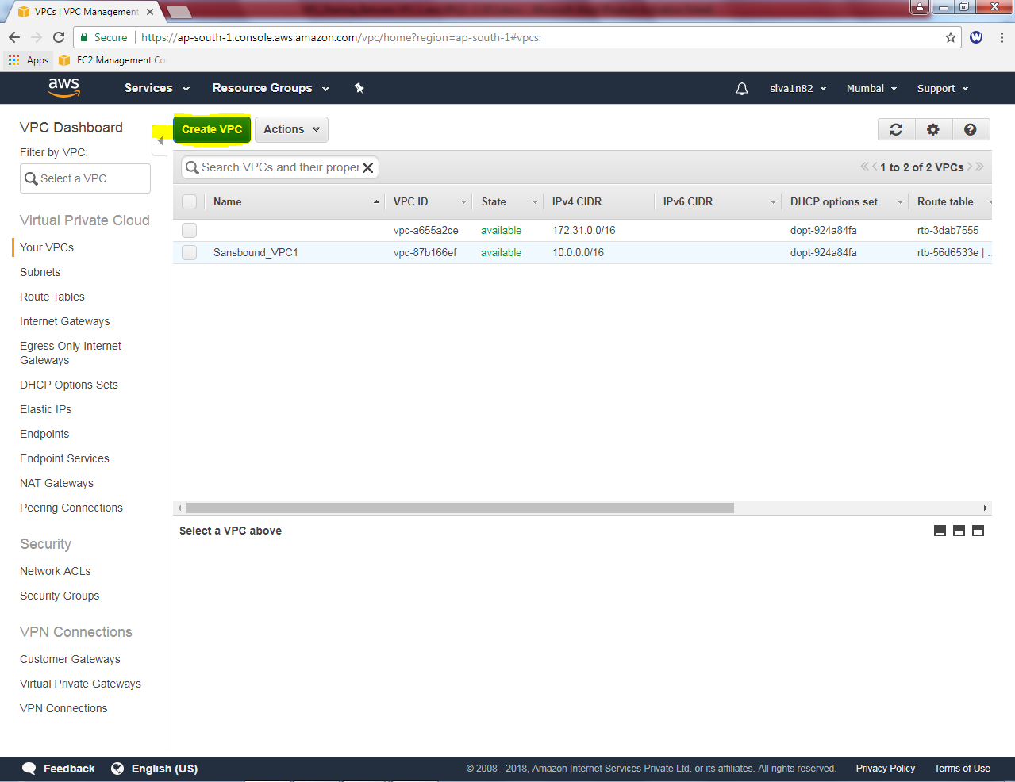

While creating VPC, name tag as “Sansbound_VPC2”.

IPV4 CIDR block as 192.168.0.0/16 subnet

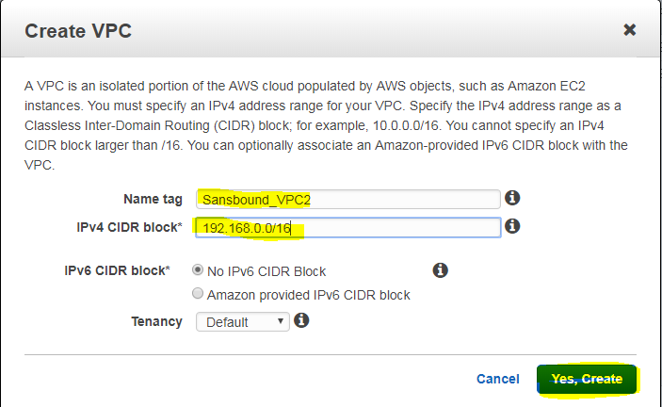

click “Yes, create”.

Then we need to create subnet for the Sansbound_VPC2.

In VPC Dashboard, click Subnet, then click “create subnet”.

While creating subnet,

Name tag as “Sansbound_VPC2_Public_Subnet”.

VPC as Sansbound_VPC2.

Availability Zone – 1B (Optional)

IPv4 CIDR Block – 192.168.2.0/24 subnet.

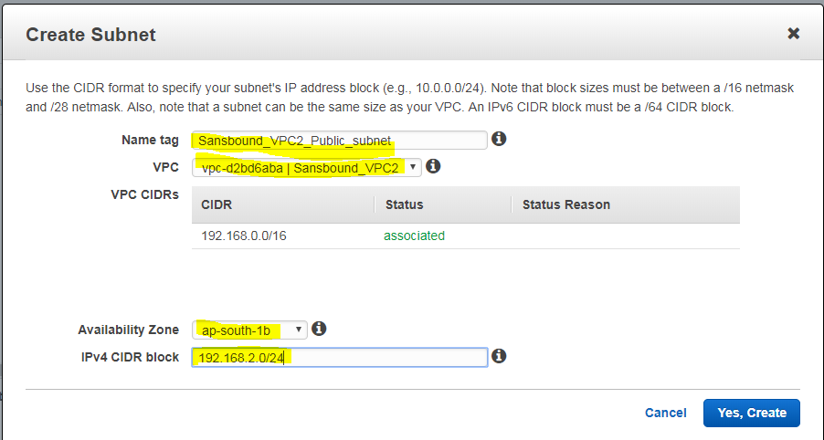

Click “Yes, create”.

Then we need to create an internet gateway, click “create Internet Gateway”.

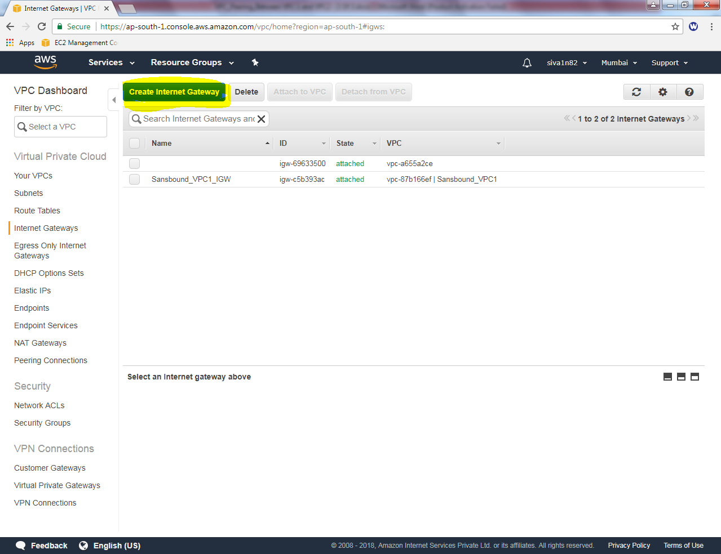

While creating internet gateway Name tag as “Sansbound_VPC2_IGW”.

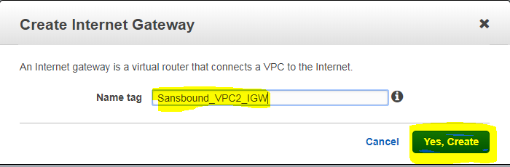

It shows, IGW in detached state, we need to attach VPC.

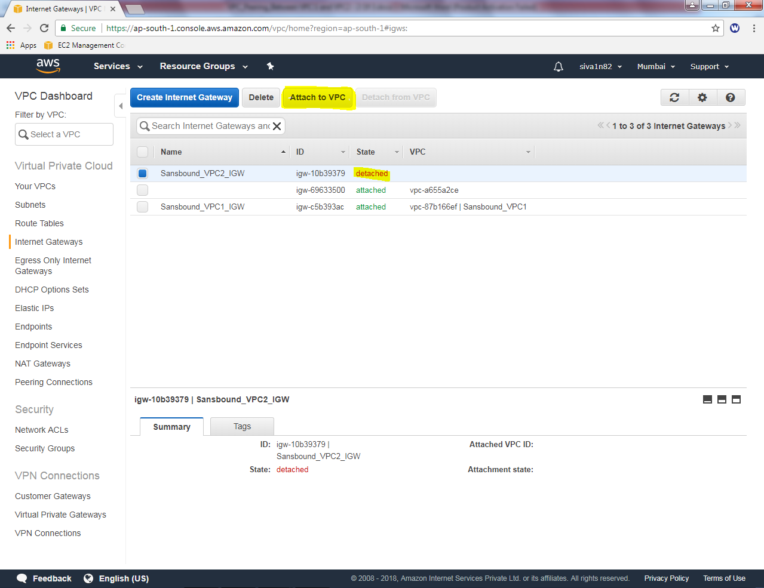

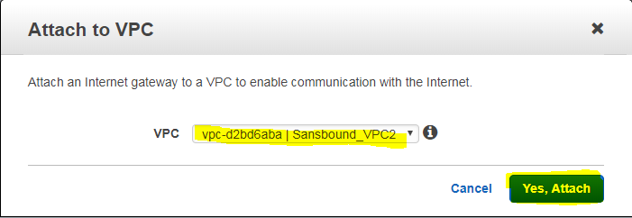

Click “Yes, Attach”.

Rename the Sansbound_VPC1 route table as sansbound_VPC2_public_route.

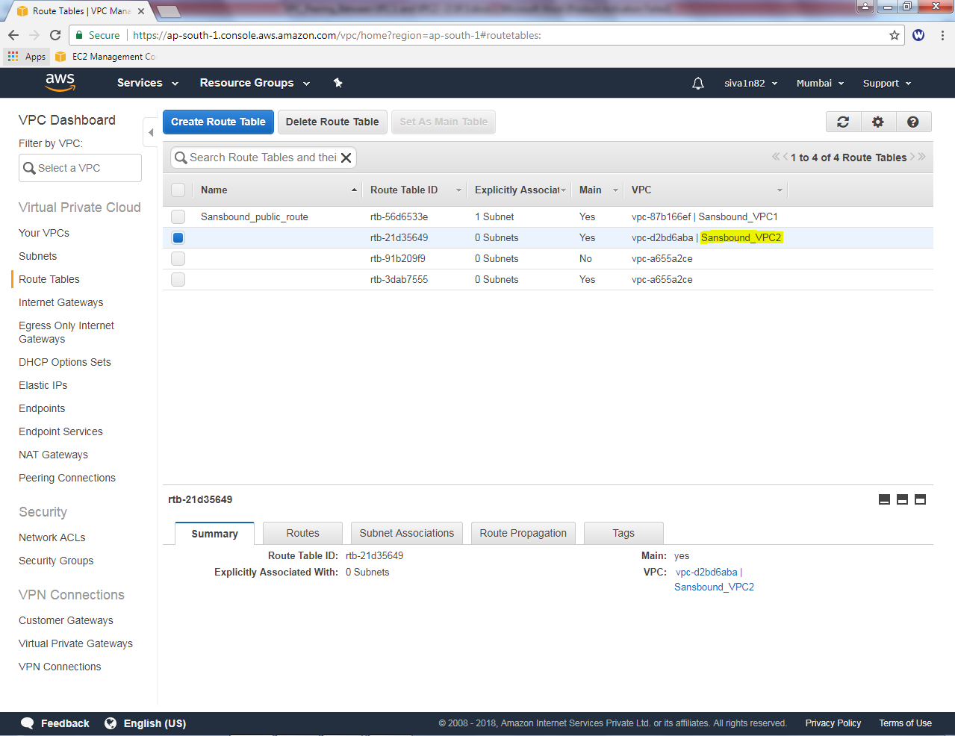

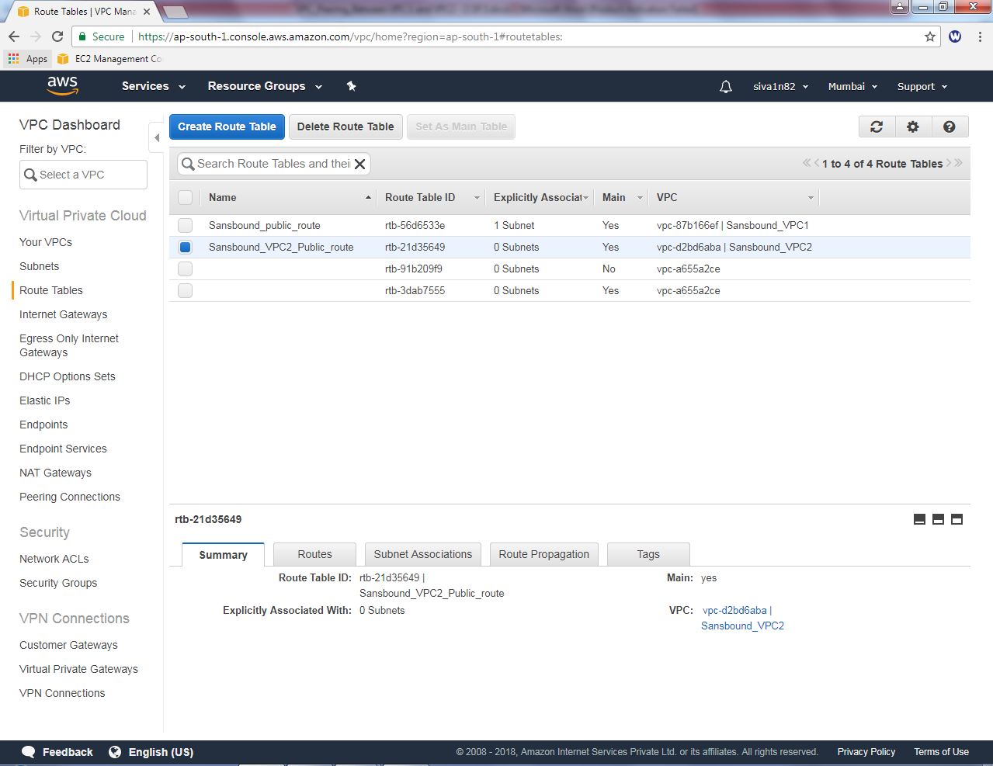

InSanbound_VPC2_Public_route table, select route tab then click “Edit” option.

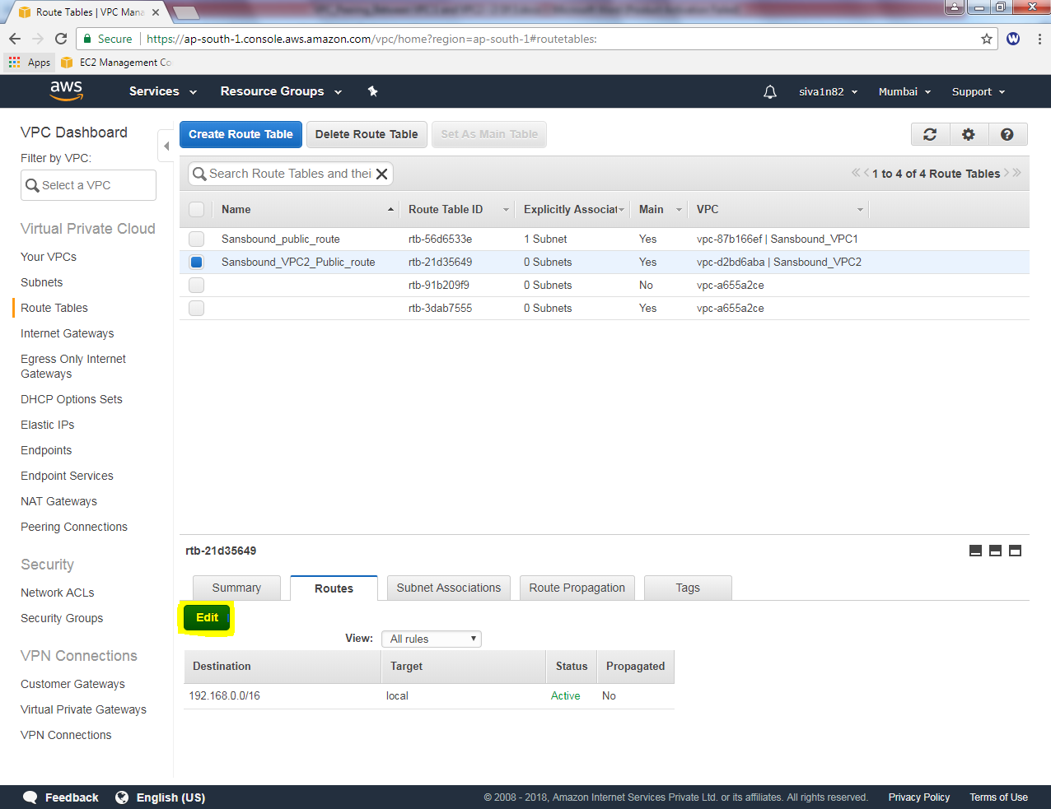

Click “Add another route”button.

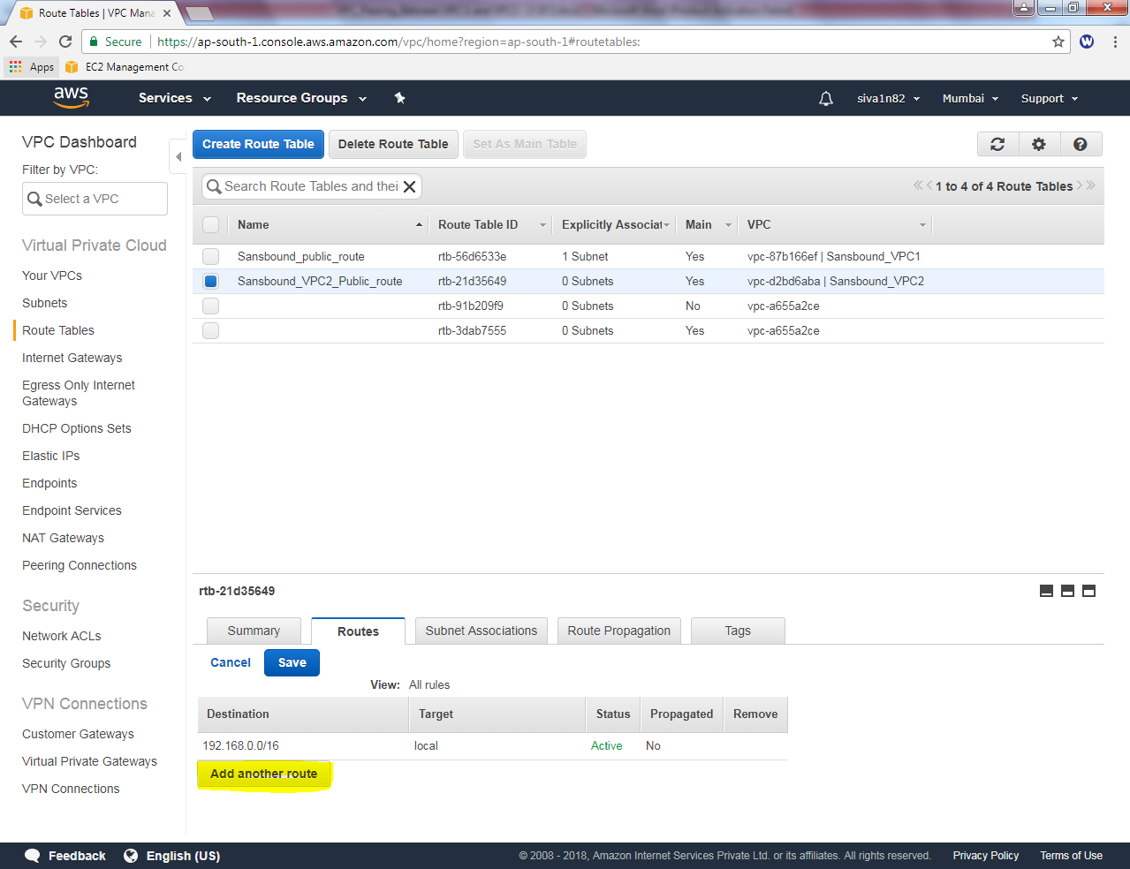

Add default route 0.0.0.0/0 and select **”igw-*”** as target.

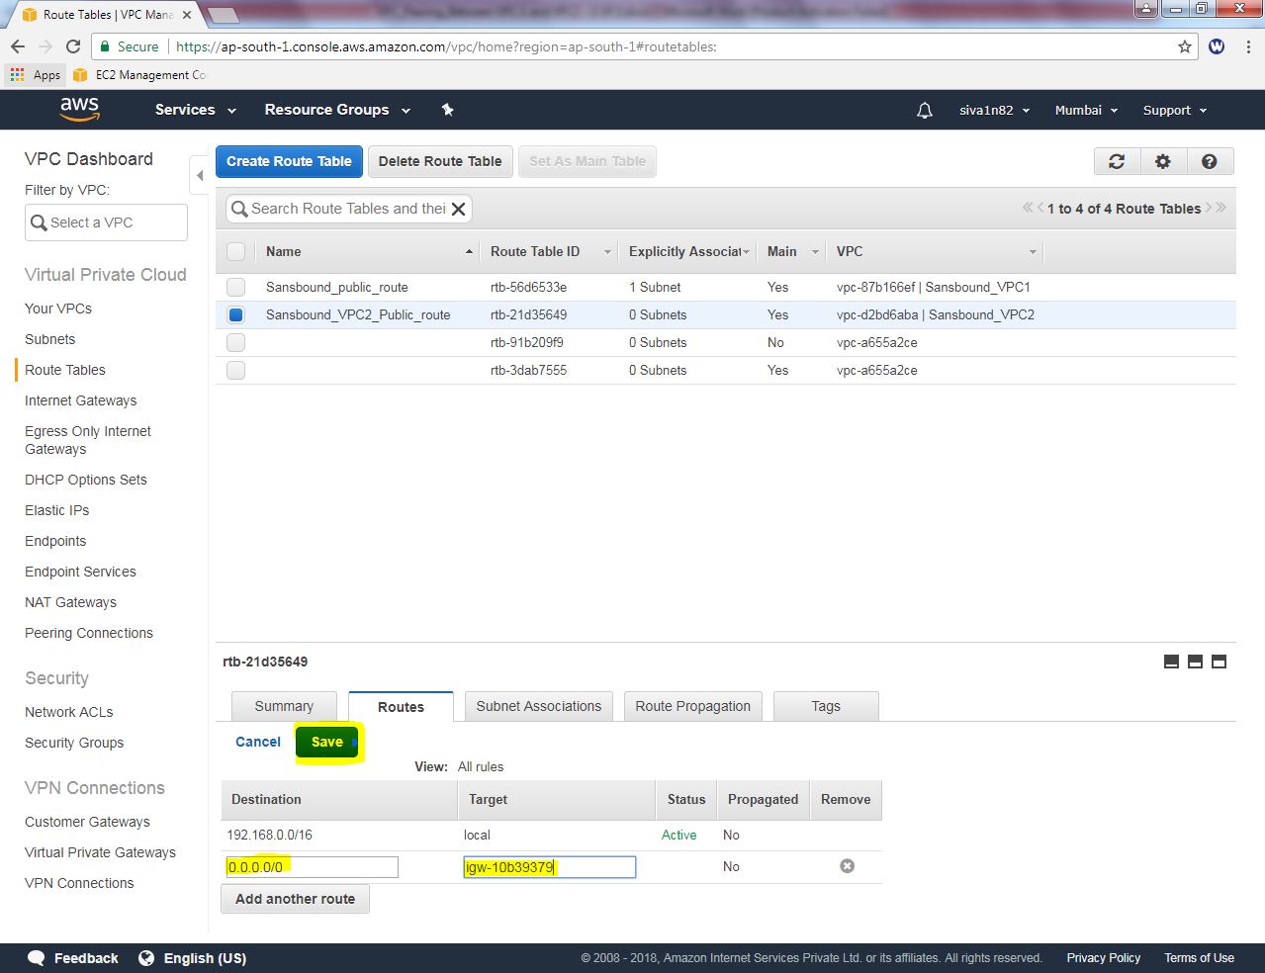

Then click “save”.

Then we need to associate the subnet. Click “Subnet associations” tab, then click “Edit” option.

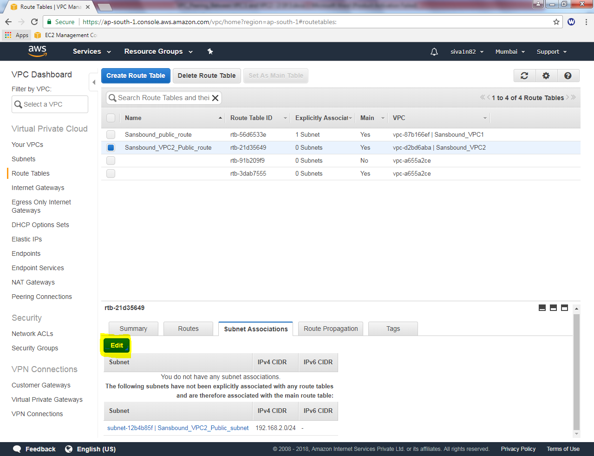

Select option check box option to select “sansbound_VPC2_Public_subnet”.

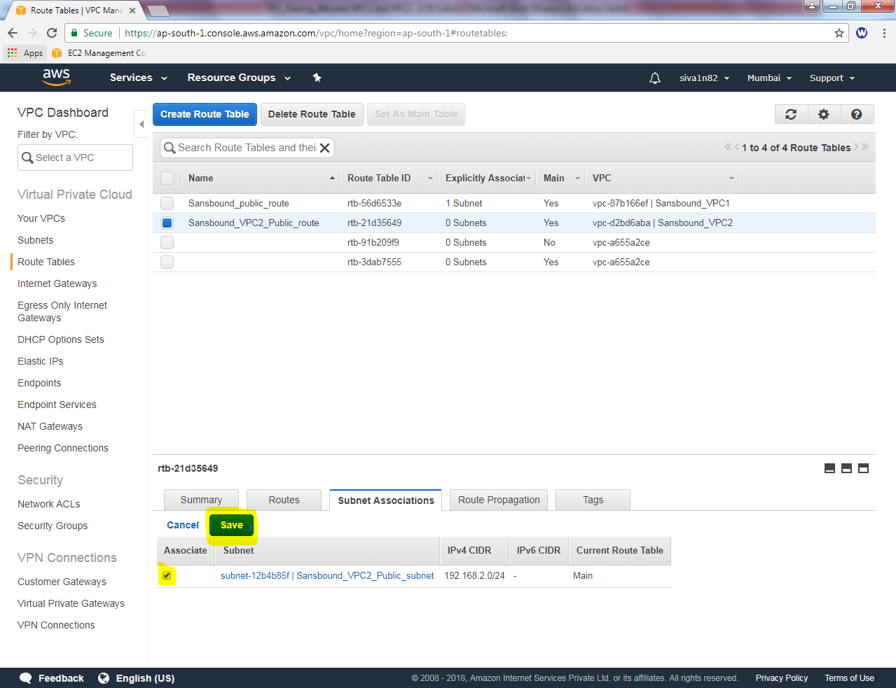

Then click “Save”.

Then we need to create an instance for VPC2. Click “Launch Instance”.

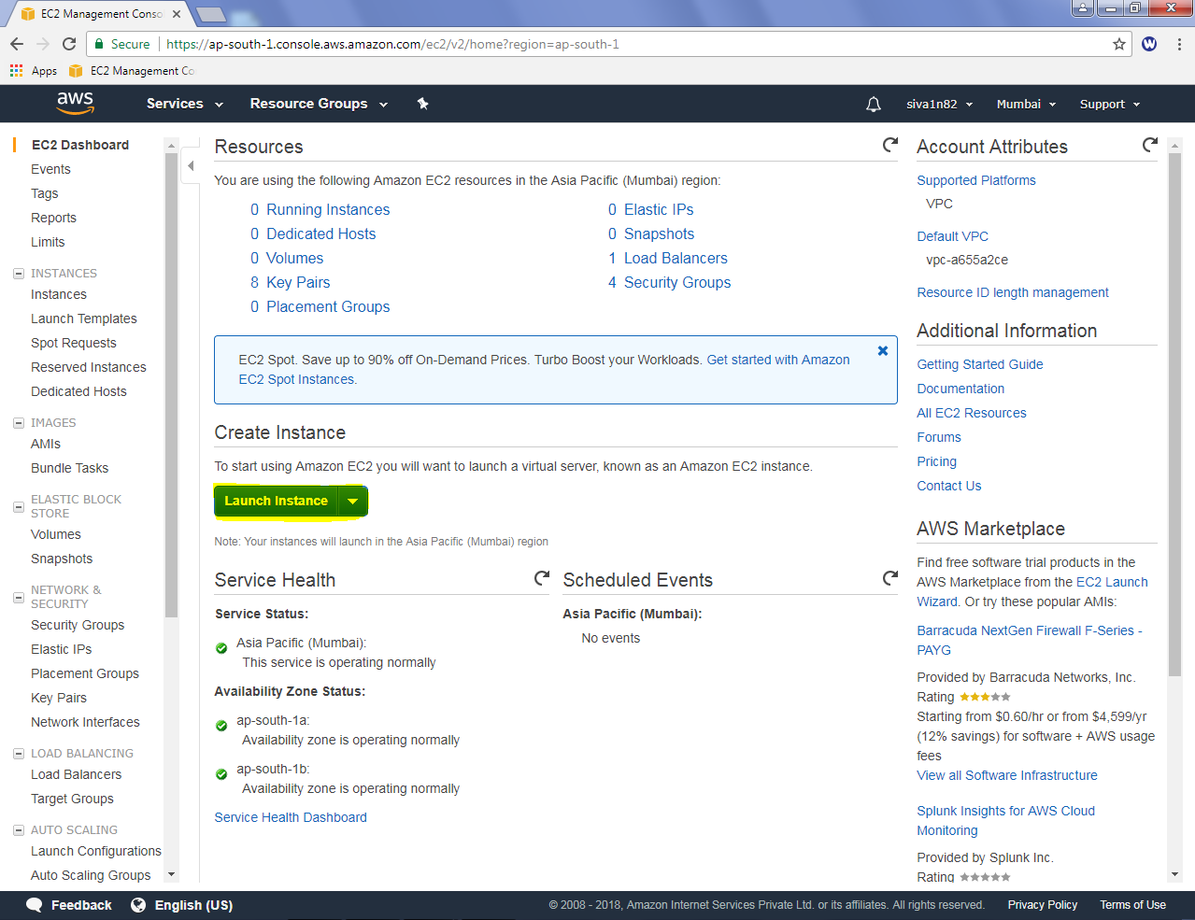

Select “Microsoft Windows server 2016 Base “option.

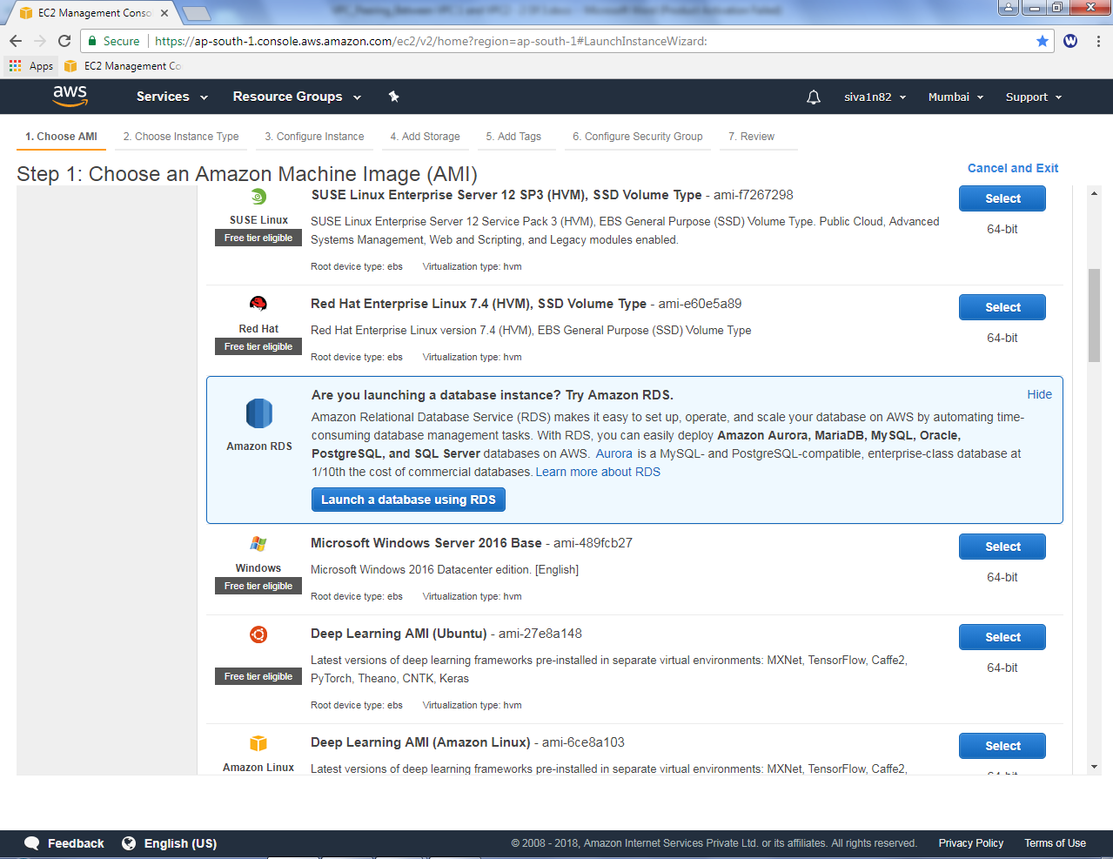

Select “t2.micro”.

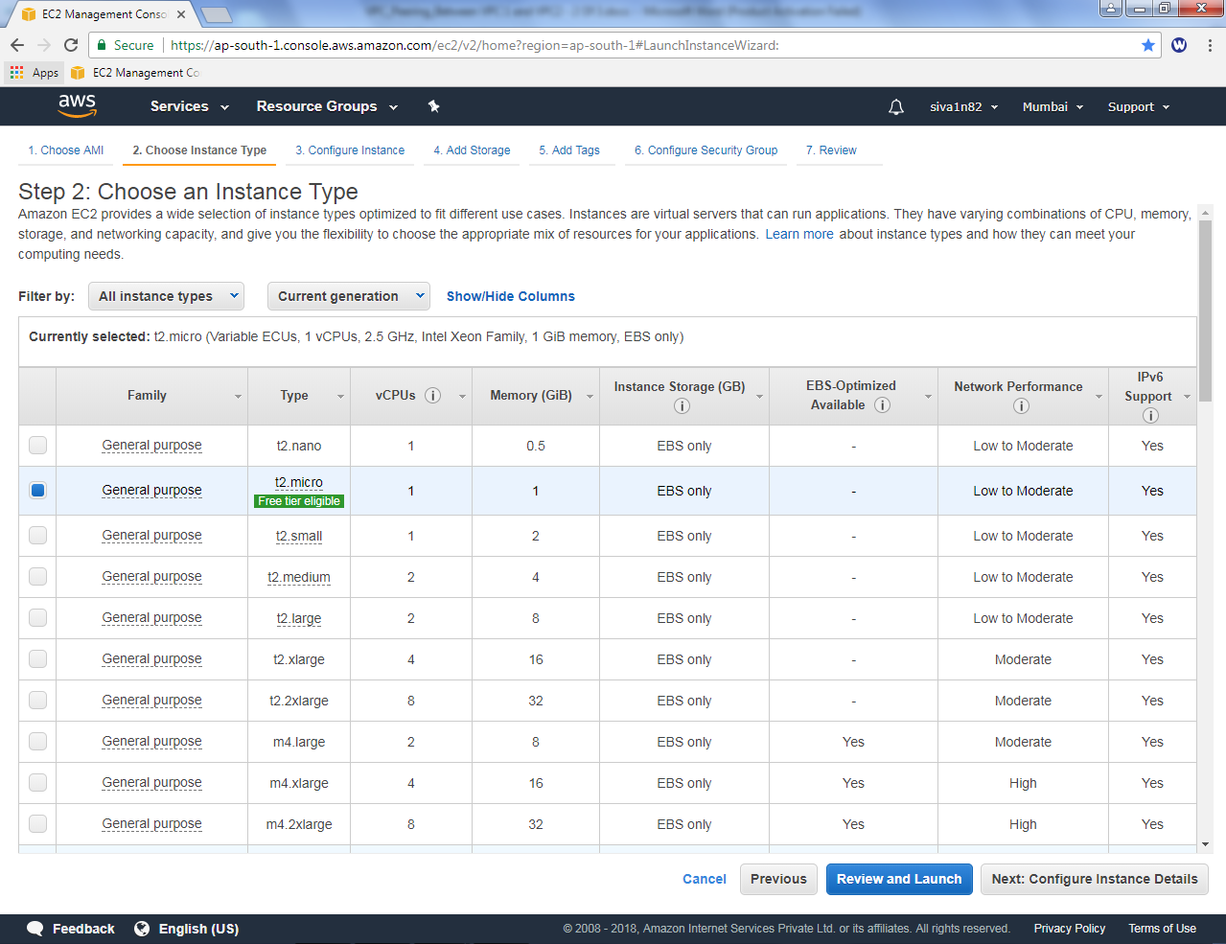

Click “Next”.

Select network as “Sansbound_VPC2”

Select subnet as Sansbound_VPC2_public_Subnet

Auto-assign Public IP: Enable

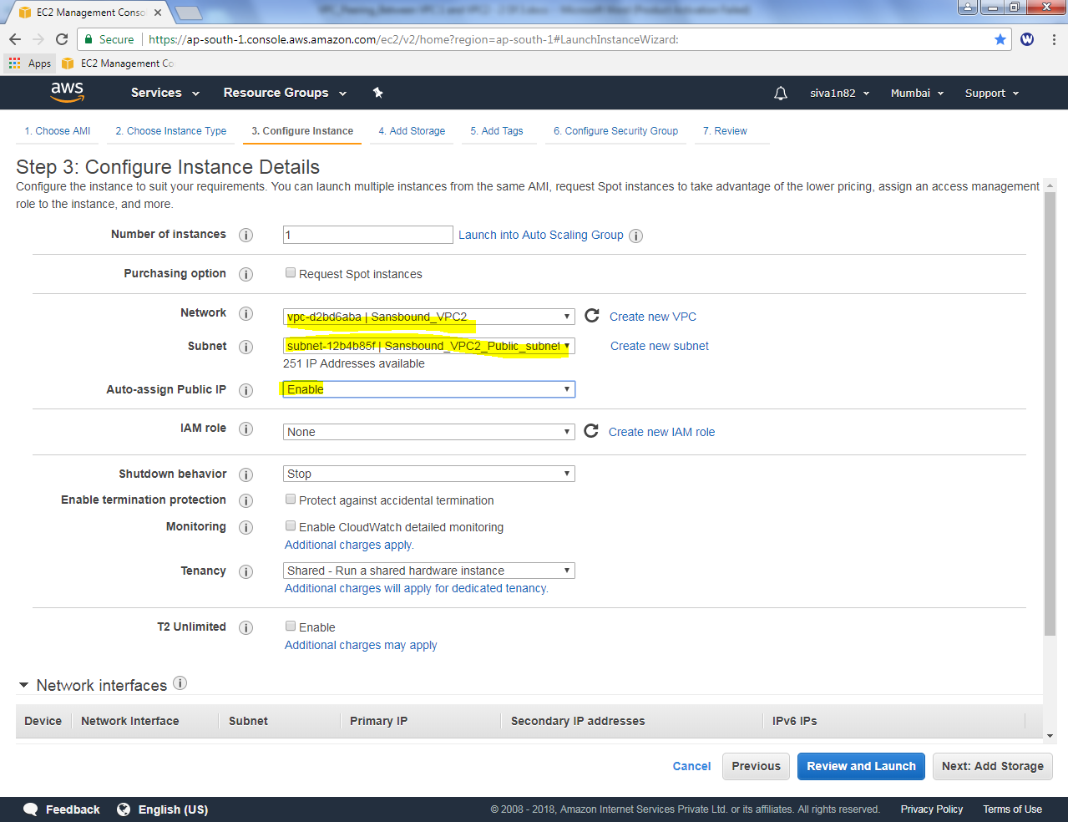

Click “Next”.

Leave default and click “Next”.

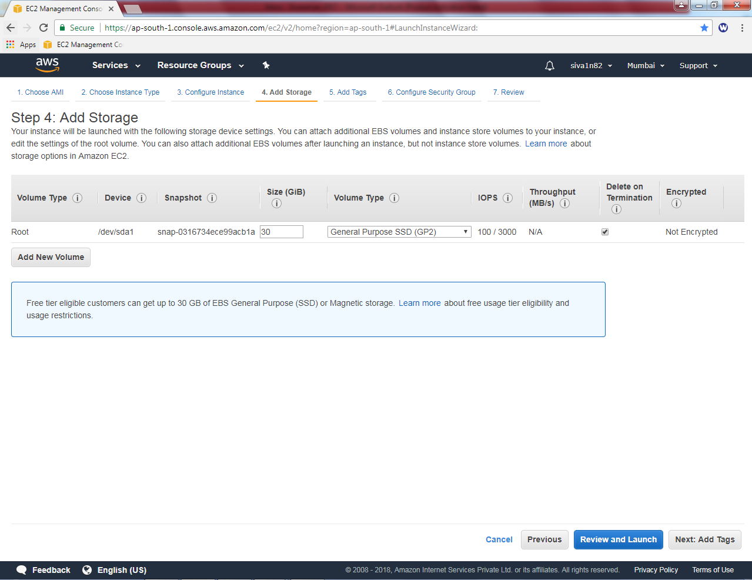

Type key as “name”and Value as VPC2 Public Instance.

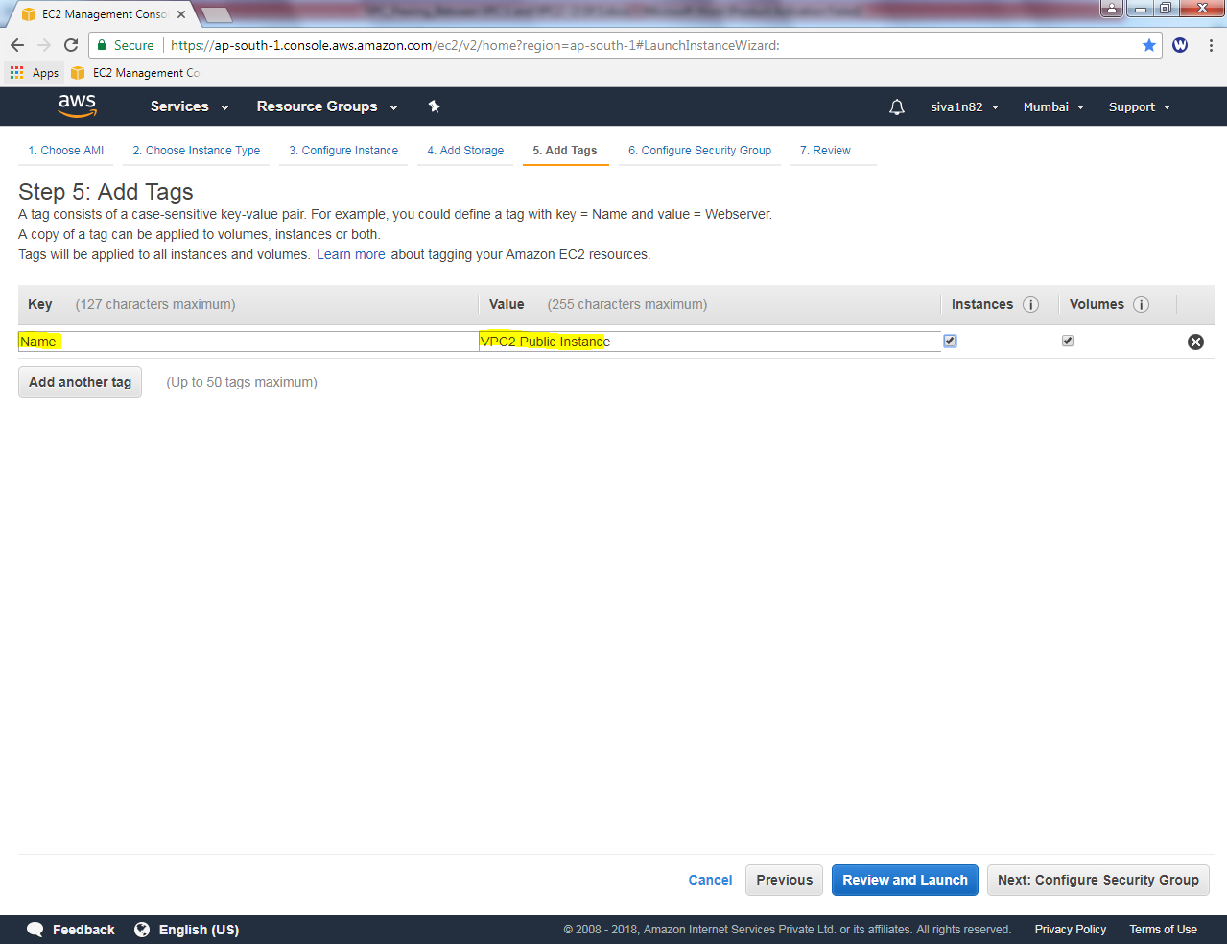

Click “Next”.

Create a new security group as “VPC2_Security_Public_Sec_Group”. Allow RDP (3389 Port).

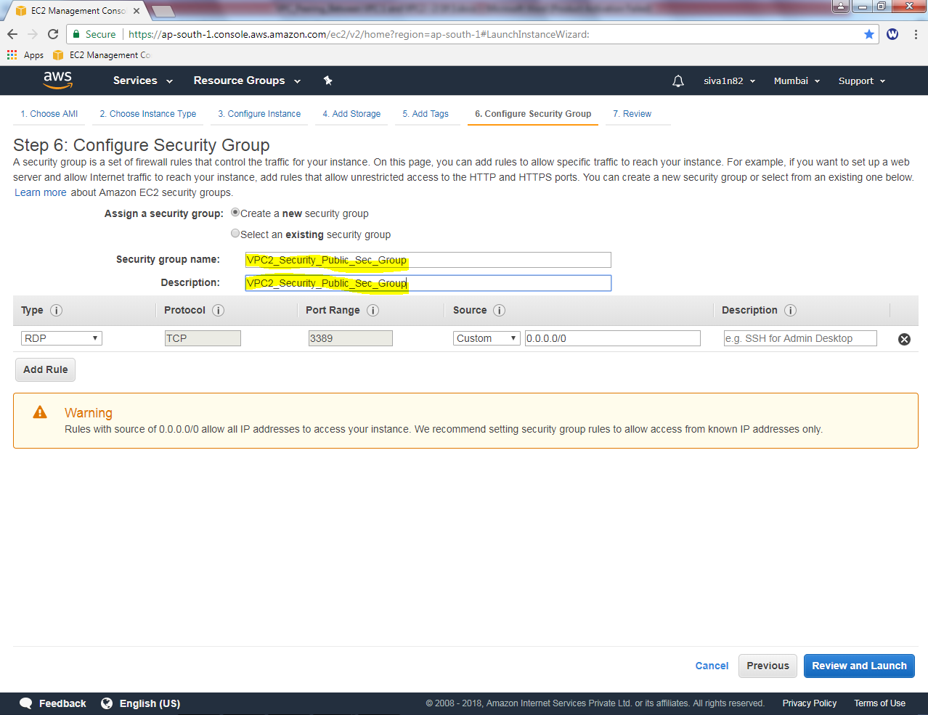

Click “Review and Launch”.

Click “Launch”.

